

L. J. Institute of Computer Application

L. J. University

Master of Computer Application

3rd Semester

Project Name :-
CarZen: Car Selling, Reselling, Service & Resale Price Prediction System

Submitted To: Mrs. Dharmi Doshi

Submitted By:

Boghara Aayush M | Roll No: E01 | 25004401110004
Chudasama Vishal B | Roll No: E02 | 25004401110069
Sakariya Pinak B | Roll No: E06 | 25004401110067

Introduction

Problem Definition
The existing process of buying, selling, and servicing cars is often dependent on manual searches, individual dealers, classified advertisements, and personal estimation of vehicle prices. Buyers may find it difficult to determine whether a car is fairly priced, while sellers may not know the appropriate resale value of their vehicle.
There is also a lack of an integrated platform that combines car buying, car selling, vehicle service information, and resale-price prediction in a single system.
The proposed CarZen system aims to develop an integrated vehicle marketplace and management platform that allows users to list cars for sale, search and compare available cars, manage resale information, access service-related information, and estimate the expected resale price of a vehicle using a machine-learning-based prediction system.
The frontend will be developed using Flutter. The backend will be developed using Python and FastAPI, while MySQL will store user, vehicle, selling, reselling, service, and prediction-related information.

Objective of the New System
The main objective is to develop an integrated platform for car buying, selling, reselling, servicing, and resale-price prediction.
    - Provide a platform for users to buy and sell new or used cars.
    - Allow sellers to create and manage car listings.
    - Allow buyers to search and filter cars according to their requirements.
    - Provide detailed information about available vehicles.
    - Support reselling by maintaining vehicle and ownership information.
    - Provide information related to vehicle servicing and maintenance.
    - Predict the estimated resale price of a car using machine learning.
    - Store system data securely and consistently using MySQL.
    - Provide REST APIs using FastAPI for communication with the Flutter frontend.
    - Provide an admin module for managing users, cars, services, listings and system data.
    - Reduce the difficulty of estimating the market value of used cars.
    - Improve transparency between buyers and sellers.

Core Components
Component | Description
User Management | Registration, login, authentication, profile management and role-based access.
Car Management | Vehicle attributes, listings, search and filtering.
Car Selling Module | Create, update, delete and manage vehicle listings and selling status.
Car Buying/Search Module | Search, filter, compare and view available vehicles.
Reselling Module | Ownership chain, purchase information, resale listing and resale history.
Car Service Module | Service type, date, cost, center, maintenance details and service history.
Resale Price Prediction Module | Estimate expected resale value from relevant vehicle characteristics and historical data.
Admin Module | Manage users, cars, listings, service information, prediction records and system data.
FastAPI Backend | RESTful APIs connecting Flutter, business logic, database and prediction services.
MySQL Database | Primary relational database for structured application data.

Project Profile
Attribute | Specification
Project Name | CarZen — Car Selling, Reselling, Service and Resale Price Prediction System
Project Type | Cross-platform application / marketplace platform
Domain | Automobile / E-Commerce / Machine Learning
Frontend | Flutter
Backend Language | Python
Backend Framework | FastAPI
Database | MySQL
API Architecture | REST API
Prediction | Machine Learning
Main Users | Buyers, Sellers, Resellers/Dealers, Car Owners, Service Providers and Administrator
Main Purpose | Car buying, selling, reselling, service management and resale-price prediction

Need of the New System
    - Difficulty in determining the correct car price: users may not know the market value of a used vehicle.
    - Lack of centralized information: car information, selling information and service records may be distributed across different sources.
    - Manual price estimation: resale prices are often estimated from personal experience rather than a consistent data-driven method.
    - Difficulty in finding suitable cars: buyers need efficient search and filtering.
    - Limited vehicle history information: previous ownership and service information may not be easily available.
    - Lack of integrated service management: service information is often maintained separately.
    - Need for an organized used-car workflow: buying and reselling activities benefit from a centralized platform.
    - Need for data-driven prediction: machine learning can estimate resale price from historical and current vehicle attributes.

Scope of the New System
Scope Area | Included Functions
Buyer Scope | Registration/login; search; filtering; comparison; vehicle details; expected resale price; seller information; service information.
Seller Scope | Seller registration; car listing; vehicle information/images; asking price; update/remove listing; selling status.
Reselling Scope | Add resale vehicle; ownership information; previous purchase details; resale-price  estimate; resale listing; resale history.
Service Scope | Add service records; view service history; service dates; service costs; maintenance information.
Prediction Scope | Use historical/current vehicle attributes to estimate expected resale price.
Admin Scope | Manage users, vehicles, listings, service records, prediction data, reported content and system activity.

Advantages of the Proposed System
    - Provides a single platform for car buying, selling and reselling.
    - Makes it easier to search and filter vehicles.
    - Helps users estimate the resale value of a car.
    - Maintains vehicle, ownership and service information.
    - Provides secure and structured data management using MySQL.
    - Helps buyers and sellers make better pricing and purchasing decisions.

Limitations of the Proposed System
    - Prediction accuracy depends on the quality of available data.
    - Predicted price may differ from the actual market price.
    - Incorrect vehicle information can affect the prediction result.
    - The system requires a reliable internet connection.
    - Service and prediction features may have limited coverage during the initial implementation.

Proposed Time Line Chart
Phase | Activities | Duration | Progress
Phase 1 | Requirement Analysis | Week 1 | ✓
Phase 2 | System Analysis and Planning | Week 2 | ✓
Phase 3 | Database Design using MySQL | Week 3 | ✓
Phase 4 | System and API Design | Week 4 | ✓
Phase 5 | User and Authentication Module | Week 5 | ✓
Phase 6 | Car Buying and Selling Module | Week 6
Phase 7 | Reselling Module | Week 7
Phase 8 | Car Service Module | Week 8
Phase 9 | Dataset Preparation and ML Model | Week 9
Phase 10 | Resale Price Prediction Integration | Week 10
Phase 11 | Testing and Bug Fixing | Week 11
Phase 12 | Documentation and Final Deployment | Week 12

1.9 Targeted Users
User Type | Main Purpose / Responsibilities
Buyers | Search for and purchase new or used cars; view details, service information and predicted resale value.
Sellers | List vehicles, set prices, update listings and manage selling status.
Car Resellers / Dealers | Manage multiple vehicles, ownership information and resale listings.
Car Owners | Maintain vehicle/service information and determine expected resale value.
Service Providers | Add and update vehicle maintenance records and service history.
Administrator | Manage users, vehicles, listings, services, prediction records and overall system operations.

Requirement Determination and Analysis

Requirement Determination
Requirement determination identifies the main requirements needed to develop and operate the CarZen – Car Selling, Reselling, Service & Resale Price Prediction System.
The major requirements are:

Functional Requirements
    - User registration and login.
    - User profile management and authentication.
    - Add, update and delete car information.
    - Create and manage car listings.
    - Search and filter available cars.
    - View detailed vehicle information.
    - Manage favourites and inquiries.
    - Maintain ownership and resale information.
    - Maintain vehicle service records.
    - Predict estimated resale price using Machine Learning.
    - Admin management of users, cars and listings.

Non-Functional Requirements
    - Security: Secure authentication and authorization.
    - Performance: Fast response to user requests.
    - Reliability: Maintain consistent and accurate data.
    - Scalability: Support increasing users and vehicle records.
    - Usability: Simple and user-friendly interface.
    - Maintainability: Modular and easily maintainable backend.

Technical Requirements
    - Frontend: Flutter
    - Backend: Python + FastAPI
    - Database: MySQL
    - API: REST API
    - Machine Learning: Python ML libraries
    - Testing: Postman
    - Version Control: Git/GitHub

Requirement Specification
The following specifications define what the CarZen system should provide.

Module | Requirement
User Management | Register, login and manage user profile.
Car Management | Add, update, delete and view vehicle information.
Listing Management | Create, update and manage car sale/resale listings.
Search | Search and filter cars according to requirements.
Ownership | Maintain vehicle ownership and transaction history.
Service | Store and view vehicle service and maintenance records.
Price Prediction | Accept vehicle details and provide estimated resale price.
Favorites | Allow users to save preferred vehicles.
Inquiry | Maintain buyer-seller communication/inquiry information.
Admin | Manage users, cars, listings and system data.

Database Requirements
The system requires a relational MySQL database to store:
Users, Addresses, Cars, Car Brands, Car Models, Car Variants, Listings, Ownership History, Service Records, Favorites, Inquiries, Transactions and Price Predictions.

Machine Learning Requirements
The prediction module will use vehicle information such as brand, model, manufacturing year, mileage, fuel type, transmission, engine capacity, number of owners, condition and location to estimate the resale price.

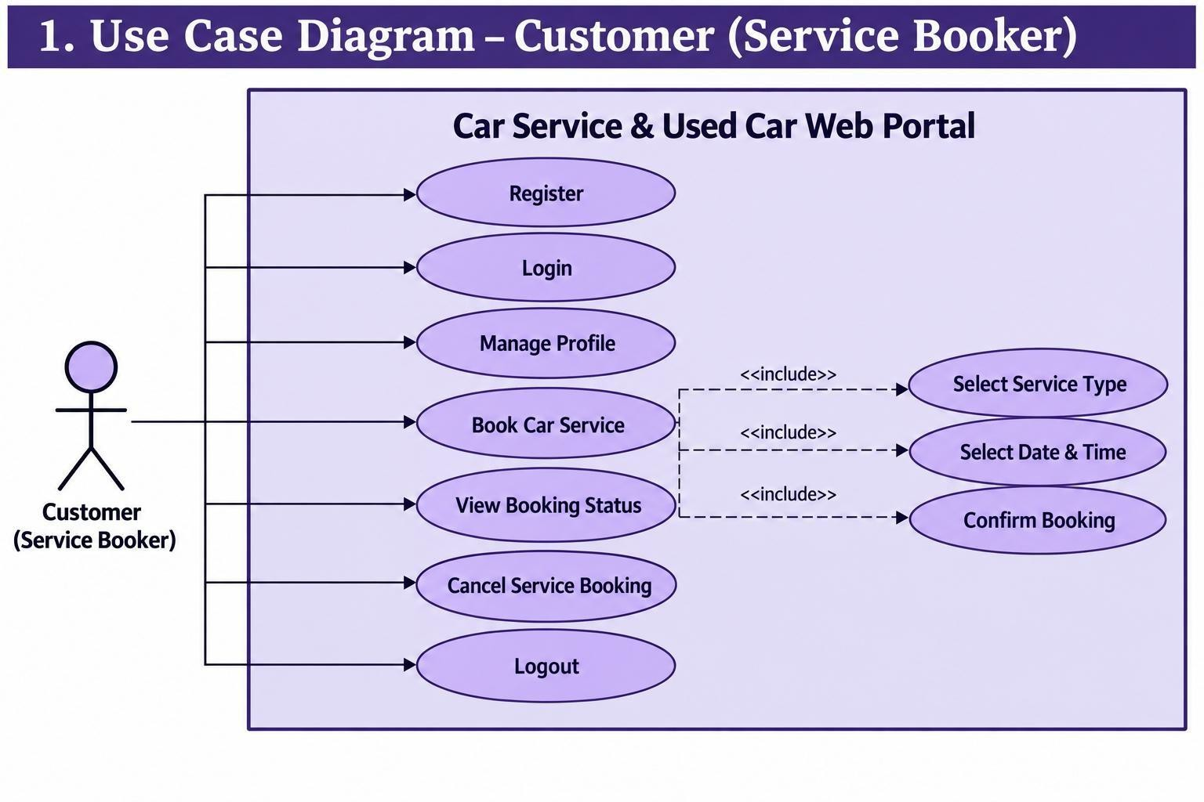
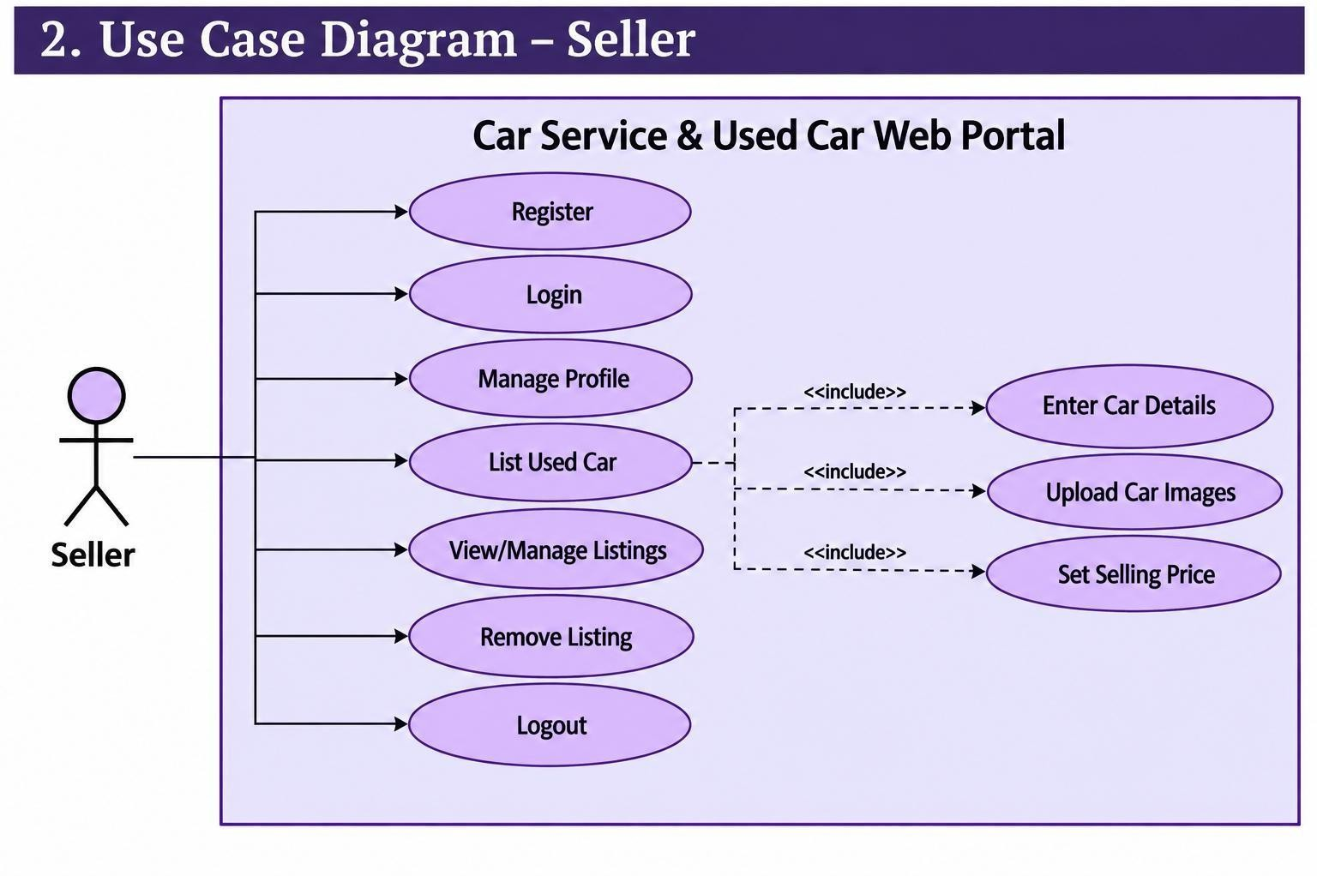
System Design

Use Case Diagram

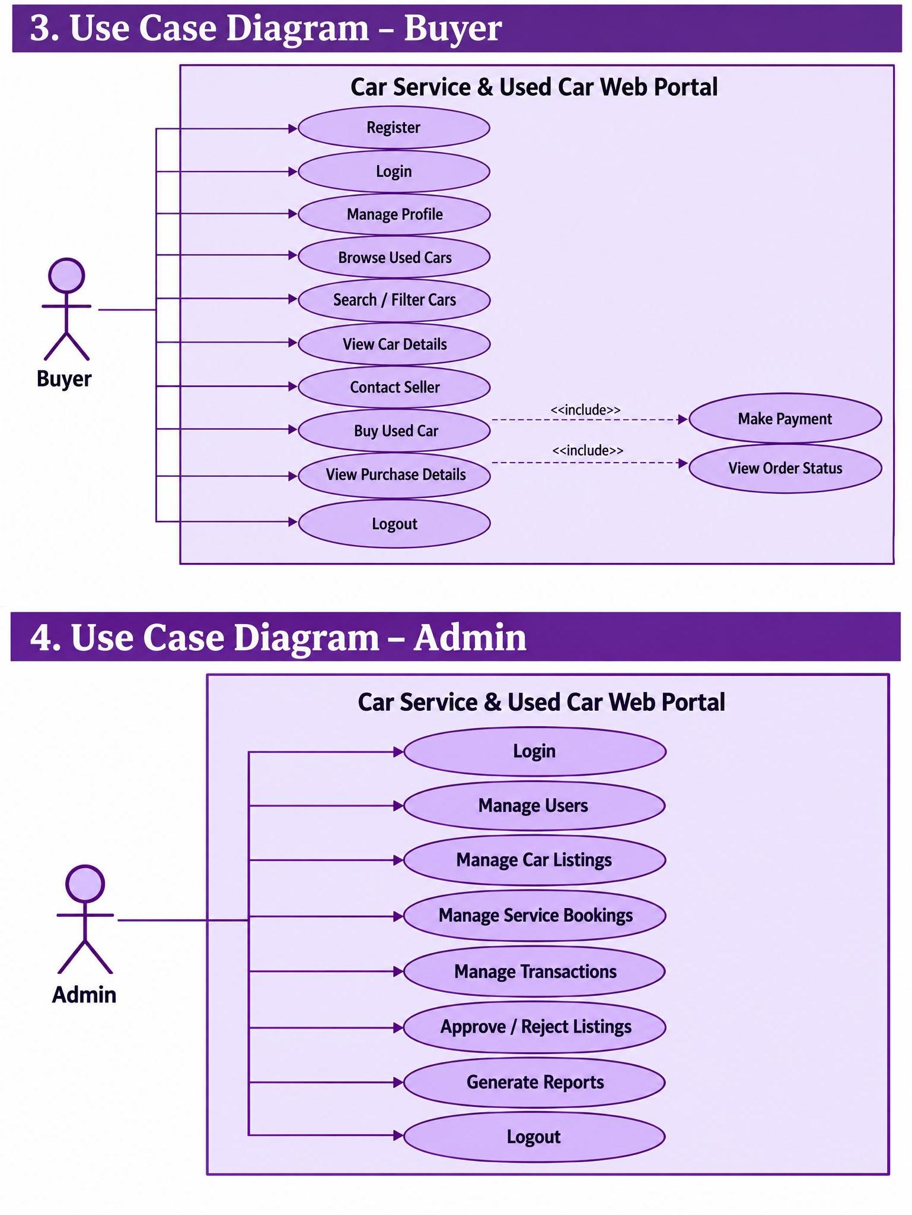

  - Data Dictionary
users
Field Name | Data Type | Nullable | Key / Default / Values | Description
id | bigint | No | PK, AUTO_INCREMENT | Unique user identifier
first_name | varchar(100) | No |  | User's first name
last_name | varchar(100) | Yes |  | User's last name
username | varchar(100) | No | UNIQUE | Unique username
email | varchar(150) | No | UNIQUE | User email address
password_hash | varchar(255) | No |  | Hashed user password
phone_number | varchar(20) | Yes | UNIQUE | User phone number
role | ENUM | No | buyer, seller, reseller, service_provider | User role
status | ENUM | Yes | active, inactive, blocked, deleted; default active | Account status
profile_image_url | varchar(500) | Yes |  | Profile image URL
created_at | timestamp | Yes |  | Record creation timestamp
updated_at | timestamp | Yes |  | Record update timestamp
deleted_at | timestamp | Yes |  | Soft deletion timestamp

addresses
Field Name | Data Type | Nullable | Key / Default / Values | Description
id | bigint | No | PK, AUTO_INCREMENT | Unique address identifier
user_id | bigint | No | FK → users.id | User owning the address
address_line_1 | varchar(255) | No |  | Primary address line
address_line_2 | varchar(255) | Yes |  | Additional address line
landmark | varchar(255) | Yes |  | Nearby landmark
city | varchar(100) | No |  | City
state | varchar(100) | No |  | State
country | varchar(100) | Yes | default India | Country
postal_code | varchar(10) | No |  | Postal/ZIP code
latitude | decimal(10,7) | Yes |  | Geographic latitude
longitude | decimal(10,7) | Yes |  | Geographic longitude
is_default | boolean | Yes | default false | Whether this is the user's default address
created_at | timestamp | Yes |  | Record creation timestamp
updated_at | timestamp | Yes |  | Record update timestamp
deleted_at | timestamp | Yes |  | Soft deletion timestamp

car_brands
Field Name | Data Type | Nullable | Key / Default / Values | Description
id | bigint | No | PK, AUTO_INCREMENT | Unique brand identifier
name | varchar(100) | No | UNIQUE | Car brand name
slug | varchar(120) | No | UNIQUE | URL-friendly brand name
country | varchar(100) | Yes |  | Brand country
logo_url | varchar(500) | Yes |  | Brand logo URL
description | text | Yes |  | Brand description
is_active | boolean | Yes | default true | Whether brand is active
created_at | timestamp | Yes |  | Record creation timestamp
updated_at | timestamp | Yes |  | Record update timestamp
deleted_at | timestamp | Yes |  | Soft deletion timestamp

car_models
Field Name | Data Type | Nullable | Key / Default / Values | Description
id | bigint | No | PK, AUTO_INCREMENT | Unique model identifier
brand_id | bigint | No | FK → car_brands.id | Associated car brand
name | varchar(100) | No |  | Car model name
slug | varchar(120) | No | UNIQUE | URL-friendly model name
body_type | ENUM | Yes | hatchback, sedan, suv, muv, coupe, convertible, pickup, minivan, other | Vehicle body type
seating_capacity | integer | Yes |  | Model seating capacity
description | text | Yes |  | Model description
is_active | boolean | Yes | default true | Whether model is active
created_at | timestamp | Yes |  | Record creation timestamp
updated_at | timestamp | Yes |  | Record update timestamp
deleted_at | timestamp | Yes |  | Soft deletion timestamp

car_variants
Field Name | Data Type | Nullable | Key / Default / Values | Description
id | bigint | No | PK, AUTO_INCREMENT | Unique variant identifier
model_id | bigint | No | FK → car_models.id | Associated car model
variant_name | varchar(150) | No |  | Variant name
fuel_type | ENUM | No | petrol, diesel, cng, electric, hybrid | Fuel type
transmission | ENUM | No | manual, automatic, amt, cvt, dct | Transmission type
engine_cc | decimal(8,2) | Yes |  | Engine displacement in cc
horsepower | decimal(8,2) | Yes |  | Engine horsepower
seating_capacity | integer | Yes |  | Variant seating capacity
ex_showroom_price | decimal(15,2) | Yes |  | Ex-showroom price
created_at | timestamp | Yes |  | Record creation timestamp
updated_at | timestamp | Yes |  | Record update timestamp
deleted_at | timestamp | Yes |  | Soft deletion timestamp

cars
Field Name | Data Type | Nullable | Key / Default / Values | Description
id | bigint | No | PK, AUTO_INCREMENT | Unique car identifier
variant_id | bigint | No | FK → car_variants.id | Car variant
owner_id | bigint | No | FK → users.id | Current owner
registration_number | varchar(30) | Yes | UNIQUE | Vehicle registration number
vin_number | varchar(100) | Yes | UNIQUE | Vehicle identification number
manufacturing_year | integer | No |  | Year of manufacture
registration_year | integer | Yes |  | Year of registration
fuel_type | ENUM | No | petrol, diesel, cng, electric, hybrid | Car fuel type
transmission | ENUM | No | manual, automatic, amt, cvt, dct | Car transmission
engine_cc | decimal(8,2) | Yes |  | Engine displacement in cc
horsepower | decimal(8,2) | Yes |  | Engine horsepower
mileage_km | decimal(12,2) | No |  | Vehicle mileage in km
color | varchar(50) | Yes |  | Car color
seating_capacity | integer | Yes |  | Number of seats
owner_count | integer | Yes | default 1 | Number of owners
ownership_type | ENUM | Yes | first_owner, second_owner, third_owner,  fourth_or_more | Ownership category
condition | ENUM | No | excellent, good, fair, poor | Vehicle condition
insurance_company | varchar(150) | Yes |  | Insurance company
insurance_type | varchar(100) | Yes |  | Insurance type
insurance_expiry | date | Yes |  | Insurance expiry date
rc_status | varchar(50) | Yes |  | Registration certificate status
city | varchar(100) | No |  | Car city
state | varchar(100) | No |  | Car state
country | varchar(100) | Yes | default India | Car country

postal_code | varchar(10) | Yes |  | Postal/ZIP code
description | text | Yes |  | Car description
expected_market_price | decimal(15,2) | Yes |  | Expected market price
is_verified | boolean | Yes | default false | Whether car is verified
created_at | timestamp | Yes |  | Record creation timestamp
updated_at | timestamp | Yes |  | Record update timestamp
deleted_at | timestamp | Yes |  | Soft deletion timestamp

car_media
Field Name | Data Type | Nullable | Key / Default / Values | Description
id | bigint | No | PK, AUTO_INCREMENT | Unique media identifier
car_id | bigint | No | FK → cars.id | Associated car
media_type | ENUM | No | image, video, document | Media type
media_url | varchar(500) | No |  | Media file URL
thumbnail_url | varchar(500) | Yes |  | Thumbnail URL
file_name | varchar(255) | Yes |  | Original file name
file_size | bigint | Yes |  | File size
sort_order | integer | Yes | default 0 | Display order
is_primary | boolean | Yes | default false | Whether media is primary
created_at | timestamp | Yes |  | Record creation timestamp
deleted_at | timestamp | Yes |  | Soft deletion timestamp

car_features
Field Name | Data Type | Nullable | Key / Default / Values | Description
id | bigint | No | PK, AUTO_INCREMENT | Unique feature identifier
car_id | bigint | No | FK → cars.id | Associated car
feature_name | varchar(150) | No |  | Feature name
feature_value | varchar(255) | Yes |  | Feature value
created_at | timestamp | Yes |  | Record creation timestamp

listings
Field Name | Data Type | Nullable | Key / Default / Values | Description
id | bigint | No | PK, AUTO_INCREMENT | Unique listing identifier
car_id | bigint | No | FK → cars.id | Car being listed
seller_id | bigint | No | FK → users.id | Seller
listing_type | ENUM | No | sale, resale | Listing type
title | varchar(255) | No |  | Listing title
description | text | Yes |  | Listing description
asking_price | decimal(15,2) | No |  | Seller asking price
negotiable | boolean | Yes | default true | Whether price is negotiable
listing_status | ENUM | Yes | draft, active, reserved, sold, expired, cancelled, removed; default draft | Listing status
listed_at | timestamp | Yes |  | Listing publication time
expiry_date | timestamp | Yes |  | Listing expiry time
views_count | integer | Yes | default 0 | Number of listing views
created_at | timestamp | Yes |  | Record creation timestamp
updated_at | timestamp | Yes |  | Record update timestamp
deleted_at | timestamp | Yes |  | Soft deletion timestamp

ownership_history
Field Name | Data Type | Nullable | Key / Default / Values | Description
id | bigint | No | PK, AUTO_INCREMENT | Unique ownership-history identifier
car_id | bigint | No | FK → cars.id | Car
owner_id | bigint | No | FK → users.id | Owner
ownership_number | integer | No |  | Sequential ownership number
ownership_type | ENUM | Yes | first_owner, second_owner, third_owner,  fourth_or_more | Ownership category
purchase_date | date | Yes |  | Purchase date
sale_date | date | Yes |  | Sale date
purchase_price | decimal(15,2) | Yes |  | Purchase price
sale_price | decimal(15,2) | Yes |  | Sale price
purchase_location | varchar(150) | Yes |  | Purchase location
sale_location | varchar(150) | Yes |  | Sale location
created_at | timestamp | Yes |  | Record creation timestamp

service_centers
Field Name | Data Type | Nullable | Key / Default / Values | Description
id | bigint | No | PK, AUTO_INCREMENT | Unique service-center identifier
owner_id | bigint | Yes | FK → users.id | Service-center owner
name | varchar(200) | No |  | Service-center name
contact_person | varchar(150) | Yes |  | Contact person
email | varchar(150) | Yes |  | Contact email
phone_number | varchar(20) | Yes |  | Contact phone
address_line_1 | varchar(255) | Yes |  | Primary address line
address_line_2 | varchar(255) | Yes |  | Additional address line
city | varchar(100) | Yes |  | City
state | varchar(100) | Yes |  | State
country | varchar(100) | Yes | default India | Country
postal_code | varchar(10) | Yes |  | Postal/ZIP code
latitude | decimal(10,7) | Yes |  | Geographic latitude
longitude | decimal(10,7) | Yes |  | Geographic longitude
rating | decimal(3,2) | Yes |  | Service-center rating
is_verified | boolean | Yes | default false | Whether service center is verified
is_active | boolean | Yes | default true | Whether service center is active
created_at | timestamp | Yes |  | Record creation timestamp
updated_at | timestamp | Yes |  | Record update timestamp
deleted_at | timestamp | Yes |  | Soft deletion timestamp

service_records
Field Name | Data Type | Nullable | Key / Default / Values | Description
id | bigint | No | PK, AUTO_INCREMENT | Unique service-record identifier
car_id | bigint | No | FK → cars.id | Serviced car
service_center_id | bigint | Yes | FK → service_centers.id | Service center
service_type | varchar(150) | No |  | Type of service
service_date | date | No |  | Service date
odometer_reading | decimal(12,2) | Yes |  | Odometer reading
service_cost | decimal(15,2) | Yes |  | Total service cost
parts_cost | decimal(15,2) | Yes |  | Parts cost
labor_cost | decimal(15,2) | Yes |  | Labor cost
description | text | Yes |  | Service description
next_service_date | date | Yes |  | Next scheduled service date
next_service_mileage | decimal(12,2) | Yes |  | Next service mileage
status | ENUM | Yes | scheduled, completed, cancelled; default  completed | Service status

service_items
Field Name | Data Type | Nullable | Key / Default / Values | Description
id | bigint | No | PK, AUTO_INCREMENT | Unique service-item identifier
service_record_id | bigint | No | FK → service_records.id | Service record
item_name | varchar(150) | No |  | Serviced item/part name
quantity | integer | Yes | default 1 | Quantity
unit_cost | decimal(15,2) | Yes |  | Cost per unit
total_cost | decimal(15,2) | Yes |  | Total item cost
created_at | timestamp | Yes |  | Record creation timestamp

favorites
Field Name | Data Type | Nullable | Key / Default / Values | Description
id | bigint | No | PK, AUTO_INCREMENT | Unique favorite identifier
user_id | bigint | No | FK → users.id | User who favorited
car_id | bigint | No | FK → cars.id | Favorited car
created_at | timestamp | Yes |  | Record creation timestamp

inquiries
Field Name | Data Type | Nullable | Key / Default / Values | Description
id | bigint | No | PK, AUTO_INCREMENT | Unique inquiry identifier
listing_id | bigint | No | FK → listings.id | Related listing
buyer_id | bigint | No | FK → users.id | Buyer
seller_id | bigint | No | FK → users.id | Seller
subject | varchar(255) | Yes |  | Inquiry subject
message | text | No |  | Inquiry message
status | ENUM | Yes | open, contacted, closed; default open | Inquiry status
created_at | timestamp | Yes |  | Record creation timestamp
updated_at | timestamp | Yes |  | Record update timestamp

transactions
Field Name | Data Type | Nullable | Key / Default / Values | Description
id | bigint | No | PK, AUTO_INCREMENT | Unique transaction identifier
listing_id | bigint | No | FK → listings.id | Related listing
car_id | bigint | No | FK → cars.id | Transacted car
buyer_id | bigint | No | FK → users.id | Buyer
seller_id | bigint | No | FK → users.id | Seller
final_price | decimal(15,2) | No |  | Final transaction price
transaction_date | timestamp | Yes |  | Transaction date/time
payment_method | ENUM | Yes | cash, upi, card, bank_transfer, finance, other | Payment method
payment_status | ENUM | Yes | pending, partial, paid, failed, refunded; default pending | Payment status
transaction_status | ENUM | Yes | initiated, completed, cancelled, failed; default initiated | Transaction status
notes | text | Yes |  | Transaction notes
created_at | timestamp | Yes |  | Record creation timestamp
updated_at | timestamp | Yes |  | Record update timestamp

payments
Field Name | Data Type | Nullable | Key / Default / Values | Description
id | bigint | No | PK, AUTO_INCREMENT | Unique payment identifier
transaction_id | bigint | No | FK → transactions.id | Related transaction
amount | decimal(15,2) | No |  | Payment amount
currency | varchar(10) | Yes | default INR | Payment currency
payment_method | ENUM | Yes | cash, upi, card, bank_transfer, finance,  other | Payment method

provider | varchar(100) | Yes |  | Payment provider
provider_transaction_id | varchar(255) | Yes |  | Provider transaction reference
status | ENUM | Yes | pending, partial, paid, failed, refunded; default pending | Payment status
payment_date | timestamp | Yes |  | Payment date/time
metadata | json | Yes |  | Additional payment metadata
created_at | timestamp | Yes |  | Record creation timestamp
updated_at | timestamp | Yes |  | Record update timestamp

price_predictions
Field Name | Data Type | Nullable | Key / Default / Values | Description
id | bigint | No | PK, AUTO_INCREMENT | Unique prediction identifier
car_id | bigint | Yes | FK → cars.id | Car used for prediction
user_id | bigint | No | FK → users.id | User requesting prediction
prediction_status | ENUM | Yes | requested, completed, failed; default requested | Prediction status
predicted_price | decimal(15,2) | Yes |  | Predicted price
minimum_price | decimal(15,2) | Yes |  | Minimum predicted price
maximum_price | decimal(15,2) | Yes |  | Maximum predicted price
confidence_score | decimal(5,2) | Yes |  | Prediction confidence score
model_name | varchar(150) | Yes |  | Prediction model name
model_version | varchar(100) | Yes |  | Prediction model version
prediction_input | json | Yes |  | Input data used for prediction
prediction_date | timestamp | Yes |  | Prediction date/time
created_at | timestamp | Yes |  | Record creation timestamp

prediction_features
Field Name | Data Type | Nullable | Key / Default / Values | Description
id | bigint | No | PK, AUTO_INCREMENT | Unique prediction-feature identifier
prediction_id | bigint | No | FK → price_predictions.id | Related prediction
feature_name | varchar(100) | No |  | Prediction feature name
feature_value | varchar(255) | Yes |  | Prediction feature value
created_at | timestamp | Yes |  | Record creation timestamp

reviews
Field Name | Data Type | Nullable | Key / Default / Values | Description
id | bigint | No | PK, AUTO_INCREMENT | Unique review identifier
user_id | bigint | No | FK → users.id | Review author
car_id | bigint | Yes | FK → cars.id | Reviewed car
listing_id | bigint | Yes | FK → listings.id | Reviewed listing
rating | integer | No |  | Review rating
title | varchar(255) | Yes |  | Review title
review_text | text | Yes |  | Review content
is_visible | boolean | Yes | default true | Whether review is visible
created_at | timestamp | Yes |  | Record creation timestamp
updated_at | timestamp | Yes |  | Record update timestamp
deleted_at | timestamp | Yes |  | Soft deletion timestamp

admins
Field Name | Data Type | Nullable | Key / Default / Values | Description
id | bigint | No | PK, AUTO_INCREMENT | Unique admin identifier
user_id | bigint | No | FK → users.id, UNIQUE | Admin user
role | ENUM | No | super_admin, admin, moderator | Admin role
is_active | boolean | Yes | default true | Whether admin is active

created_at | timestamp | Yes |  | Record creation timestamp
updated_at | timestamp | Yes |  | Record update timestamp

reports
Field Name | Data Type | Nullable | Key / Default / Values | Description
id | bigint | No | PK, AUTO_INCREMENT | Unique report identifier
reporter_id | bigint | No | FK → users.id | User submitting report
listing_id | bigint | Yes | FK → listings.id | Reported listing
car_id | bigint | Yes | FK → cars.id | Reported car
reason | varchar(255) | No |  | Report reason
description | text | Yes |  | Report details
status | varchar(50) | Yes | default pending | Report status
created_at | timestamp | Yes |  | Report creation timestamp
resolved_at | timestamp | Yes |  | Resolution timestamp

notifications
Field Name | Data Type | Nullable | Key / Default / Values | Description
id | bigint | No | PK, AUTO_INCREMENT | Unique notification identifier
user_id | bigint | No | FK → users.id | Recipient user
title | varchar(255) | No |  | Notification title
message | text | No |  | Notification message
notification_type | varchar(100) | Yes |  | Notification type
reference_id | bigint | Yes |  | Referenced record identifier
reference_type | varchar(100) | Yes |  | Referenced record type
is_read | boolean | Yes | default false | Whether notification has been read
created_at | timestamp | Yes |  | Notification creation timestamp

